# Chapter 5: Heat Health Warning Systems

Table of Contents

Chapter 5: Heat Health Warning Systems 1

Background 2

What is a Heat Health Warning System? 2

Why are Heat Health Warning Systems important? 2

Definitions of heat stress 2

Quantifying heat stress 2

What is an Extreme Heat Event? 2

How are Extreme Heat Events being defined? 2

Short-term Extreme Heat Event prediction 2

Observed variables and conditions 2

How are forecasts made? 3

What is the state of capabilities of hazard prediction? 3

Architecture of Heat Health Warning Systems 3

Quantification of Heat Health Warning Systems 3

What is the architecture of current Heat Health Warning Systems? 3

Research 3

New Heat Health Warning Systems 3

Updated Heat Health Warning Systems 3

Case studies in innovation 4

1. Developing of framework on heat-health warning system in Thailand 4

2. Defining and predicting heat waves in Bangladesh 5

3. Heat-Health Action Plan to prevent the consequences on the health of the population in the former Yugoslav Republic of Macedonia 6

4. Ahmedabad Heat Action Plan 2017 8

5. Validation of a Temperature Prediction Model for Heat Deaths in Undocumented Border Crossers 9

6. Regional Integrated Multi-Hazard Early Warning System for Africa and Asia (RIMES) 10

References 11

## Background

### What is a Heat Health Warning System?

A Heat Health Warning Systems (HHWS) is the architecture designed to establish in good time whether a potentially dangerous Extreme Heat Event (EHE) is approaching. HHWSs are the weather-based alert component of a wider Heat Health Action Plan (HHAPs), which in totality are designed to prevent negative outcomes for human health due to dangerous EHEs. When HHWSs work successfully embedded in a HHAP, they can potentially avert scores of premature deaths.

It is important that HHWSs are tailored to the local target population. For this reason, HHWSs must include elements of health data to establish where dangerous thresholds of heat stress are placed in the framework of HHWSs.

Once an EHE has been forecast and decision makers are aware of an alert, a framework should exist which allows for communication to practitioners and members of the public to best prepare to mitigate the worst impacts of the EHE.

### Why are Heat Health Warning Systems important?

Management of EHEs are critically important, as there is ample evidence that they can cause large spikes in attributable heat deaths, where otherwise they would not have occurred. EHEs are also expected to become more frequent, stronger, and longer-lasting under the onset of climate change. Vulnerable populations to this exposure are of special concern, and should be a focus of a successful HHAP.

This means that there is more impetus than ever to ensure that there are adequate systems to not only predict the onset of EHEs, but also to provide adequate warning time to ensure emergency preparedness measures are followed.

## Definitions of heat stress

### Quantifying heat stress

### What is an Extreme Heat Event?

An EHE is broadly described as a significant rise in ambient heat stress. This broad description contains numerous methods of quantifying this, using thresholds localised by mortality and morbidity data, stratified at times by geography, demographic profile, and resilience due to adaptation from conditions in the recent past.

### How are Extreme Heat Events being defined?

## Short-term Extreme Heat Event prediction

### Observed variables and conditions

### How are forecasts made?

### What is the state of capabilities of hazard prediction?

## Architecture of Heat Health Warning Systems

### Quantification of Heat Health Warning Systems

### What is the architecture of current Heat Health Warning Systems?

## Research

### New Heat Health Warning Systems

### Updated Heat Health Warning Systems

## Case studies in innovation

### Developing of framework on heat-health warning system in Thailand

**Publication**: World Health Organization1

**When published:** Not yet published (most likely 2017)

**Overview:** The report details work that has led to the development of a HHWS framework in Thailand, a country with a sub-tropical climate.

**Who involved:** - World Health Organization, Country Office for Thailand

- School of Public Health, University of Washington

- Faculty of Medicine, Chiang Mai University

- Meteorological Department, Thailand

- Bureau of Policy and Strategy, Ministry of Public Health, Thailand

**What is done:** The report identifies heat-health temperature threshold in Thailand, then develops heat-health warning criteria.

**Why interesting:** A stand-out example of how to work with multiple partners to create a from-scratch HHWS using appropriate involvement of government-level stakeholders. A relatively untapped area of the world (Asia and sub-tropical climate) introducing a clearly necessary HHWS and HHAP.

**How potentially useful:** Could be an example to show the ‘art of the possible’ for other countries in similar position.

**Suggestions for future:** Proposed as adoption and implementation as an early warning to raise awareness in a wide range of societal concern and improve decision making in preparing effective guidance on heat-voidance and mitigating heat-related illness among Thai population especially in vulnerable groups.

**Key facts and figures:** ‘The number of heat stressed morbidity is substantially increasing from 2010-2013, which is 1,020, 1,241, 1,810, 2,742 cases, respectively.’

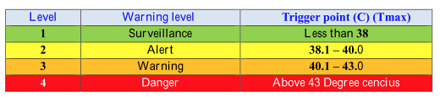

**Links:** not currently online

### Defining and predicting heat waves in Bangladesh

**Publication:** Journal of Applied Meteorology and Climatology2

**When published:** Not yet published (most likely 2017)

**Overview:** The paper proposes a heat wave definition for Bangladesh that could be used to trigger preparedness measures in a heat early warning system (HEWS). The paper also explores sources of predictability for heat waves from a weather to seasonal timescale.

**Who involved:** - The Earth Institute of Columbia University, New York, USA

- Mailman School of Public Health, Columbia University, New York, USA

- Red Cross Red Crescent Climate Centre, The Hague, The Netherlands

- Institute for Environmental Studies, VU University Amsterdam, The Netherlands

**What is done:** Uses generalized additive regression model to propose a definition of a heatwave requiring elevated minimum and maximum daily temperatures over 95th percentile for three consecutive days.

Explores sources of predictability for heat waves in Bangladesh, on both weather forecasts up to 30 days.

**Why interesting:** A stand-out example of a technical exploration of both how to classify heat waves and how best to predict them.

**How potentially useful:** Could be an example to show the ‘art of the possible’ of how expert institutions can work with decision makers to create an effective HEWS tailored to local requirements, working within limitations of health and weather data from developing LMICs.

**Suggestions for future:** Provide weather forecasts for heat wave risk in Bangladesh.

Explore sources of predictability for forecasts on sub-seasonal to seasonal timescales, such as soil moisture.

**Key facts and figures:** ‘Low soil moisture increases the odds of heat wave occurrence for 10 to 30 days, indicating that sub-seasonal forecasts of heat wave risk may be possible by monitoring soil moisture conditions.’

‘Mortality increased by 22% (95% CI: 8-38%) on day-and-night heat wave days, and by 24% ‘(95%CI: 10-40%) on humid-day-and-night heat wave days’.

‘We conclude that day-and-night and humid-day-and-night indicators are 17 the best predictors of mortality from the six indices tested, and we focus on these for the remaining analyses.’

**Links:** <http://journals.ametsoc.org/doi/abs/10.1175/JAMC-D-17-0035.1>

### Heat-Health Action Plan to prevent the consequences on the health of the population in the former Yugoslav Republic of Macedonia

**Publication:** World Health Organization3

**When published:** 2011

**Overview:** The report details work that has led to the development of a HHWS framework in FYRM with the help of the German government.

**Who involved:** - World Health Organization, Regional Office for Europe

- Federal Ministry for the Environment, Nature Conservation and Nuclear Safety,

Germany

- FYRM government (more specific?)

**What is done:** Develops a HHWS for FYRM (called ALERT) as part of a wider HHAP, using 5 meteorological regions countrywide, classifying into 4 warning levels.

Website created ([www.toplotnibranovi.mk)](http://www.toplotnibranovi.mk)) to ‘monitor heat-wave announcements in the FYRM’.

Created threshold temperatures for alerts from health data using Gaius allocation for determining threshold air-temperature values.

**Why interesting:** Demonstrates an example of how another country with expertise (in this case Germany) could work with another with relatively limited resources to provide an operational HHWS and HHAP system.

Clear evaluation structure of how HHWS and HHAP after each summer.

**How potentially useful:** Shows two European partners working together to create a HHWS from scratch

**Suggestions for future:** Implementation of HHAP in FYRM

**Key facts and figures:** ‘In the FYRM over 60% of the population lives in the cities.’

‘According to projections for mortality trends in the country and Skopje for the period after 2035, an increase of only 1C in average monthly temperatures compared to the period 1996-200 will significantly influence the distribution of total mortality expressed as a monthly average. This increase in the monthly mortality rate would be 4-11% higher in the months of April, May and June and an average of 10% higher compared to the period April, May, and June 1995-2004’

‘During the heat-waves in 2007, there were 1000 more deaths during the summer period in comparison to the average for the same period 2004-2007’.

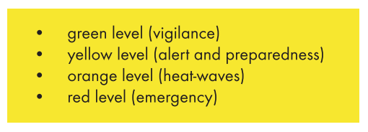

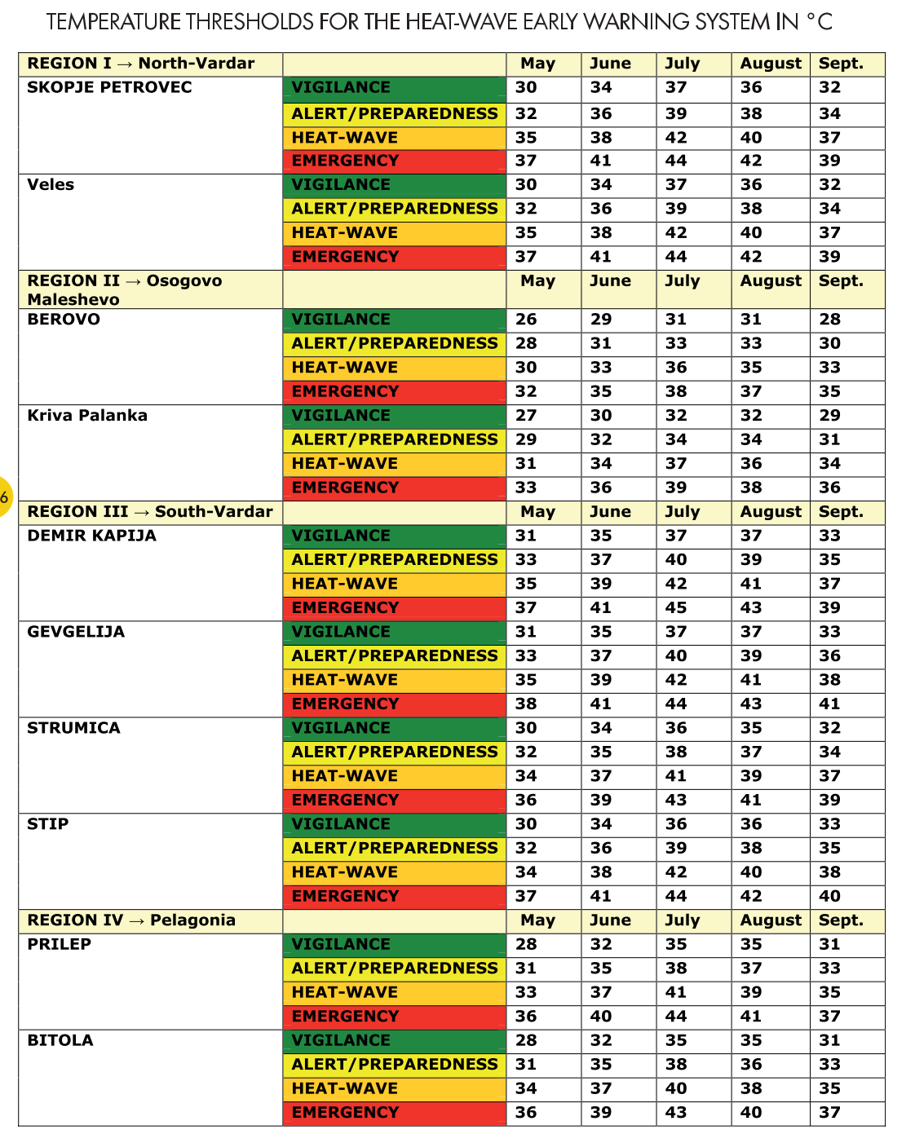

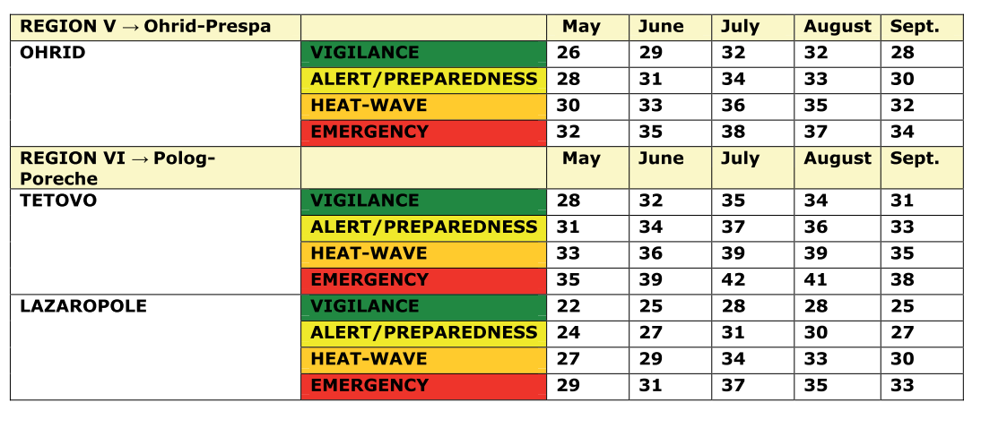

Links: http://www.euro.who.int/en/countries/the-former-yugoslav-republic-of-macedonia/publications3/heat-health-action-plan-to-prevent-the-heat-wave-consequences-on-the-health-of-the-population-in-the-former-yugoslav-republic-of-macedonia

http://www.euro.who.int/__data/assets/pdf_file/0019/215524/PROTECTING-HEALTH-FROM-CLIMATE-CHANGE-A-seven-country-initiative.pdf

### Ahmedabad Heat Action Plan 2017 and Development and Implementation of South Asia’s First Heat-Health Action Plan in Ahmedabad (Gujarat, India)

**Publication:** NRDC4, International Journal of Environmental Research and Public Health5

**When published:** 2014, 2017

**Overview:** The report gives an update on the operational Ahmedabad Heat Action Plan, providing ‘a framework for the implementation, coordination, and evaluation of extreme heat response activities in Ahmedabad that reduce the negative health impacts of extreme heat.’

**Who involved:** - Ahmedabad Municipal Corporation (AMC)

- India Meteorological Department (IMD)

- Indian Institute of Public Health, Gandhinagar

- Public Health Foundation of India

- Natural Resources Defense Council (NRDC)

- Natural Resources Defense Council

- Mount Sinai School of Medicine

- Climate & Development Knowledge Network

- School of Public Health, University of Washington

- School of Earth and Atmospheric Sciences, Georgia Institute of Technology, Atlanta

**What is done:** Uses forecasts from a system based on ‘ECMWF Variable Ensemble Prediction System (VarEPS) that is statistically post-processed and calibrated to adjust for model bias in a manner similar to previous work conducted at Georgia Tech’ to create a 7-day probabilistic weather forecast, now brought in-house at IMD.

Developed range of alert levels based on health data (confirm?)

**Why interesting:** Took mix of public and academic to improve forecasting system based on lack of former adequate advance warning from IMD (previously 1 day forecast)

**How potentially useful:** Demonstrates technical partnership of between meteorological agency and academic institutions to create functional warning system.

**Suggestions for future:** Capacity building (more specific?)

**Key facts and figures:** ‘One of India’s fastest growing cities, Ahmedabad is the economic center of the state of Gujarat. Ahmedabad district, including the surrounding suburban and rural areas, is home to 7.2 million people.’

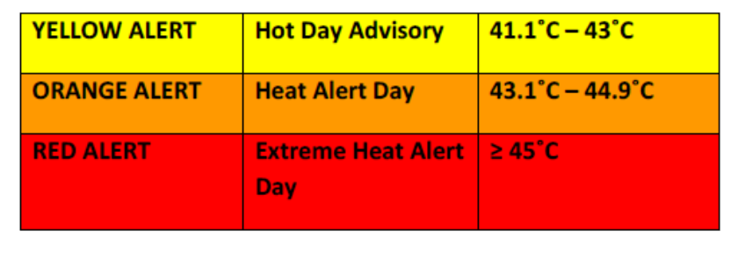

**Links:** https://www.nrdc.org/sites/default/files/ahmedabad-heat-action-plan-2017.pdf

### Validation of a Temperature Prediction Model for Heat Deaths in Undocumented Border Crossers

### Regional Integrated Multi-Hazard Early Warning System for Africa and Asia (RIMES)

## References

1 World Health Organization Country Office for Thailand. Development of framework on heat-health warning system in Thailand. .

2 Nissan H, Burkart K, Mason SJ, Coughlan de Perez E, van Aalst M. Defining and predicting heat waves in Bangladesh (under review). *J Appl Meteorol Climatol* DOI:10.1175/JAMC-D-17-0035.1.

3 The Regional Office for Europe of the World Health Organization. Heat-Health Action Plan. 2011; : 60.

4 Azhar GS, Mavalankar D, Nori-Sarma A, *et al.* Ahmedabad Heat Action Plan 2017. 2014; **9**. DOI:10.1371/journal.pone.0091831.

5 Knowlton K, Kulkarni SP, Azhar GS, *et al.* Development and implementation of South Asia’s first heat-health action plan in Ahmedabad (Gujarat, India). *Int J Environ Res Public Health* 2014; **11**: 3473–92.